

**Moving Data from Peregrine to Eagle**

The preferred method is to copy or move data to the Mass Storage System (MSS) through Peregrine Data Transfer nodes then using Globus to copy data from MSS to Eagle.

An alternative method is to copy data to /scratch or /projects on Peregrine, then using Globus to move the data directly to Eagle /scratch or /projects. While this method may be faster, you will **NOT** have a backup of the data.

**Using Globus**

(You will need user id @globus.org to use Globus.

To get a Globus account, sign up on the [Globus account website](https://www.globusid.org/create).)

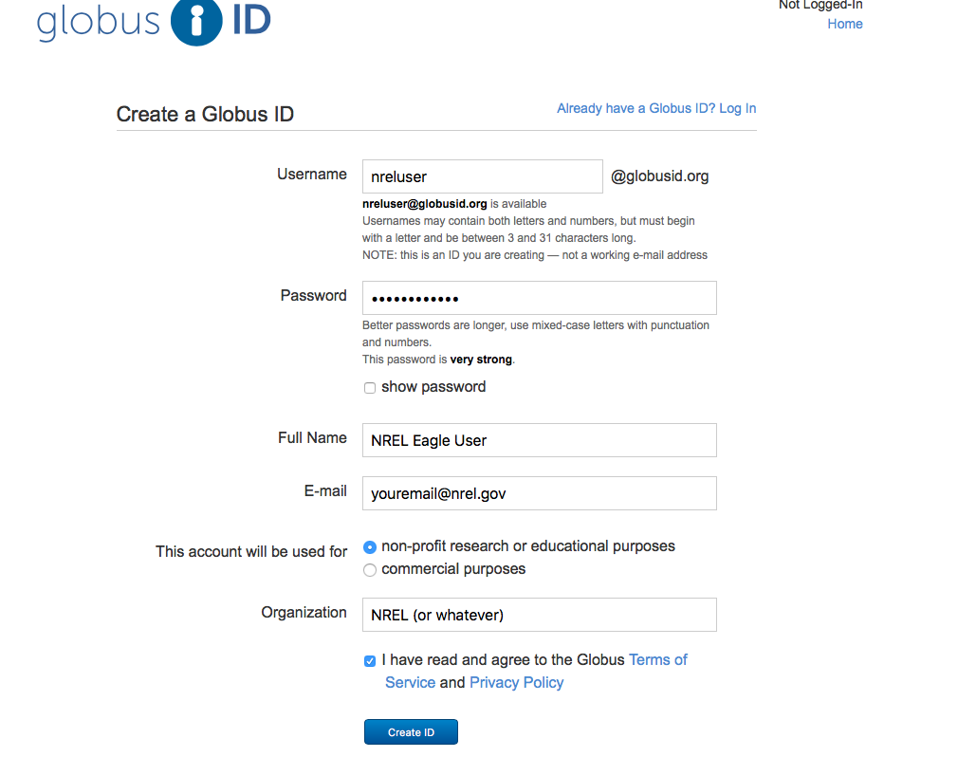

**Transferring Files and Folders using Globus**

Go to: <https://www.globusid.org/login>

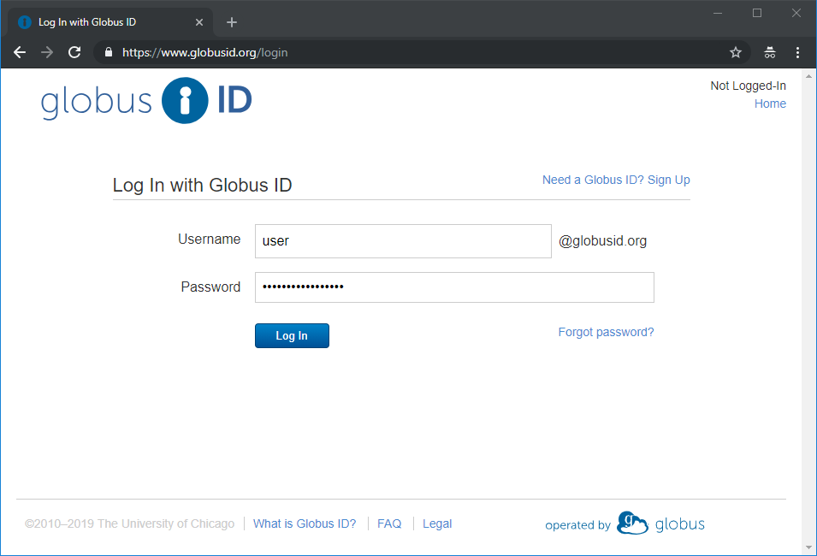

And log in with your Globus ID, e.g. [user@globusid.org](mailto:user@globusid.org) and password and click the “Log In” button.

From the File Manager tab, in the Collection Box, type in nrel# and the list of NREL’s Globus Endpoints will drop down.

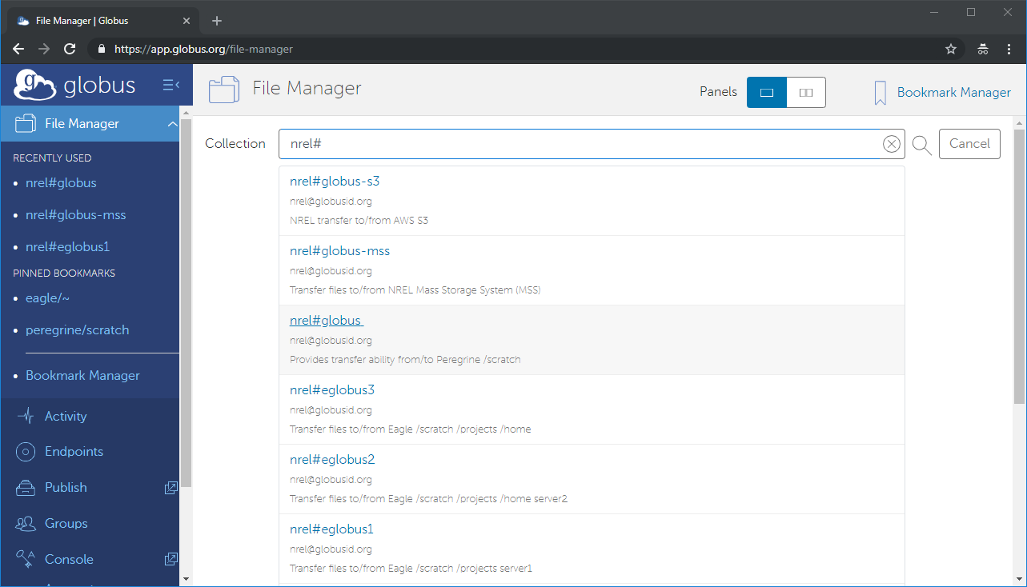

nrel#globus. This endpoint will give you access to any files you have on Peregrine:/scratch or /projects.

nrel#globus-s3. This endpoint allows you to copy files to/from AWS S3 buckets.

nrel#globus-mss. This endpoint allows you to copy files to/from NREL’s Mass Storage System (MSS).

nrel#eglobus1; nrel#eglobus2; nrel#eglobus3. These endpoints allow you to transfer files to/from Eagle’s /scratch, /projects, and your eagle /home directory

In this example, I will copy files from my MSS folder /mss/users/ to my Eagle /scratch directory.

I select nrel#globus-mss endpoint, login with my NREL username and password and click the Authenticate button.

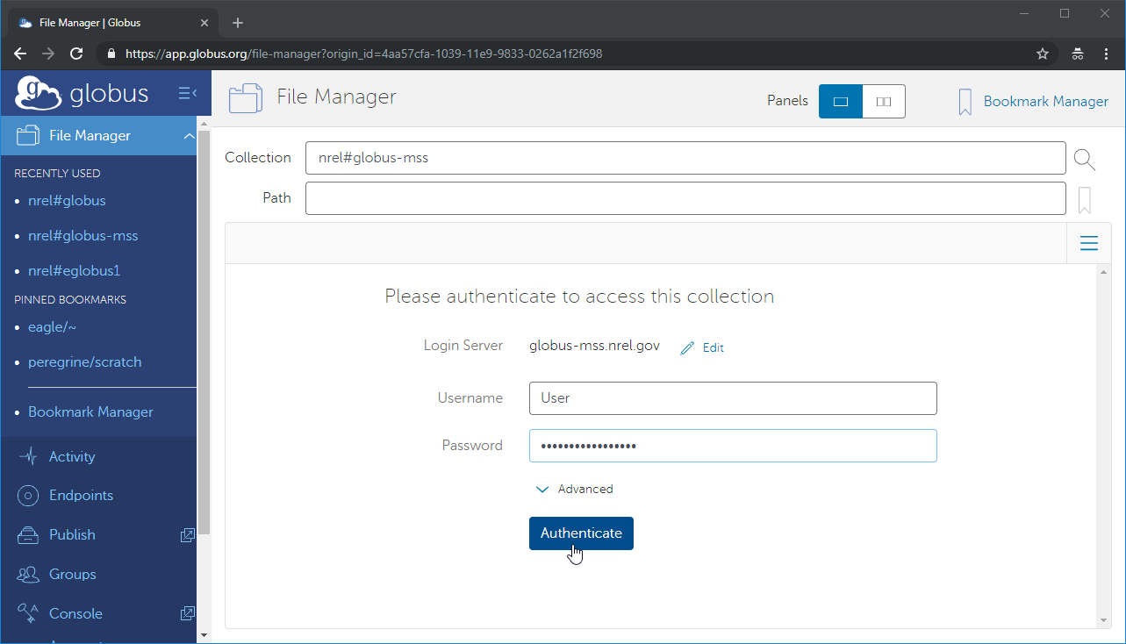

I then double click on the nfs Folder.

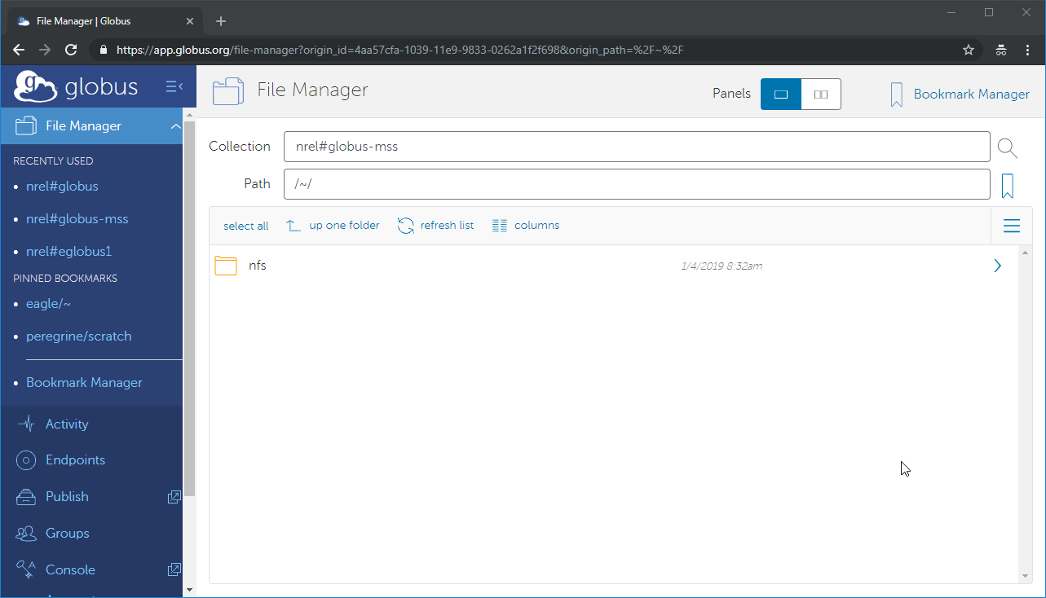

I then double click on the mss Folder

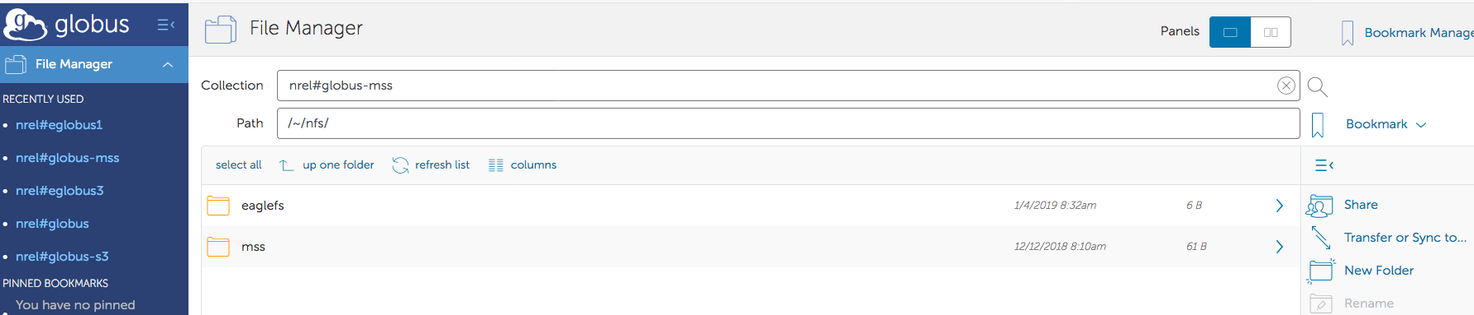

To find out which home Folder to click on, from a Peregrine login node, I “cd” to my MSS home directory, /mss/users/<username> and run the command $ df -k . (Don’t forget the period after the df -k .)

**/small1** is the home1 Folder, **/small2** is the home2 Folder, and **/small3** is the home3 Folder.

In this example, my MSS home directory is in the home2 Folder

[hpcuser@login1 hpcuser]$ pwd

/mss/users/hpcuser

[hpcuser @login1 hpcuser]$ df -k .

Filesystem 1K-blocks Used Available Use% Mounted on

192.168.100.40:/**small2** 64424453760 12065606720 52358847040 19% /mss/fs/2

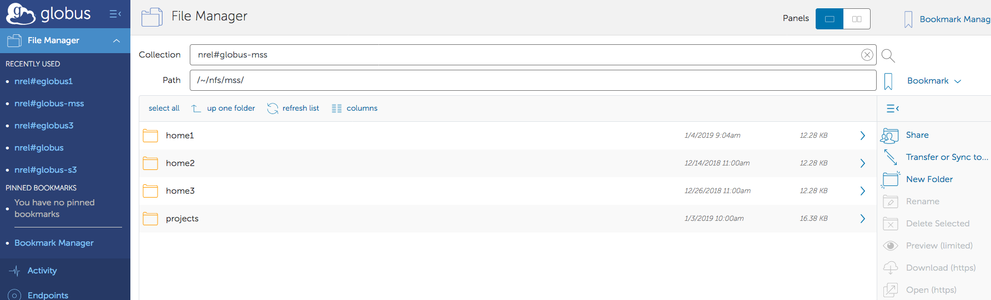

Then double click on your Folder until you get to the data you want to transfer.

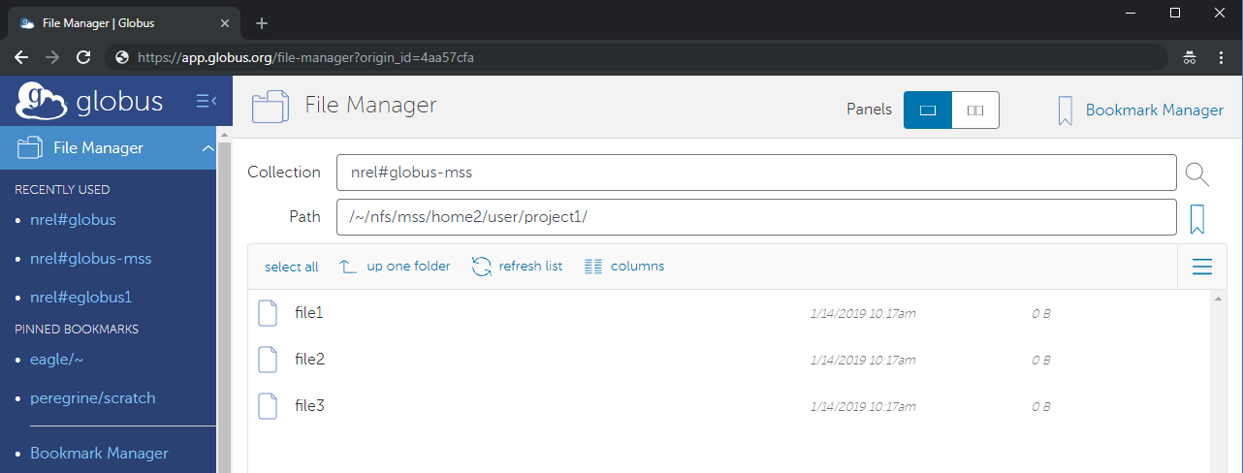

Click on the “Transfer or Sync to..” on the right menu.

This will open a split screen where you repeat the steps for where you want to transfer the data to, in this case nrel#eglobus3.

After Authenticating on nrel#globus3, the default directory is my home directory on Eagle.

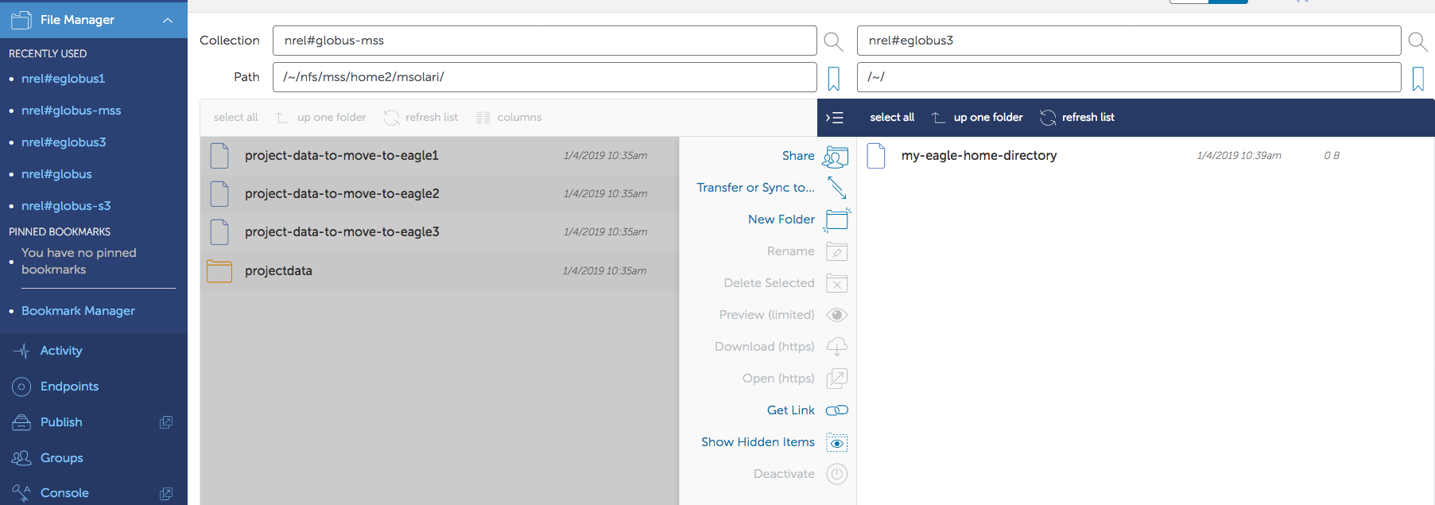

I click the “up one folder” and double click on the projects Folder, then double click on the project Folder I want to copy my data to, (/projects/<handle>/dir).

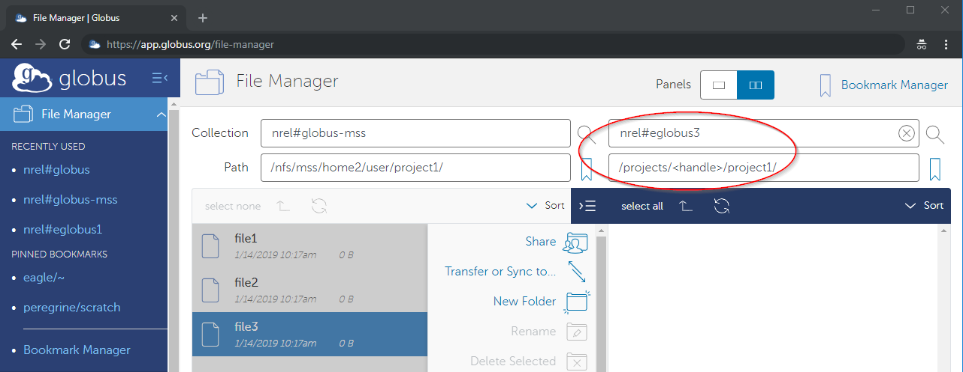

I click on the left window, highlight the files I want to transfer, then click start.

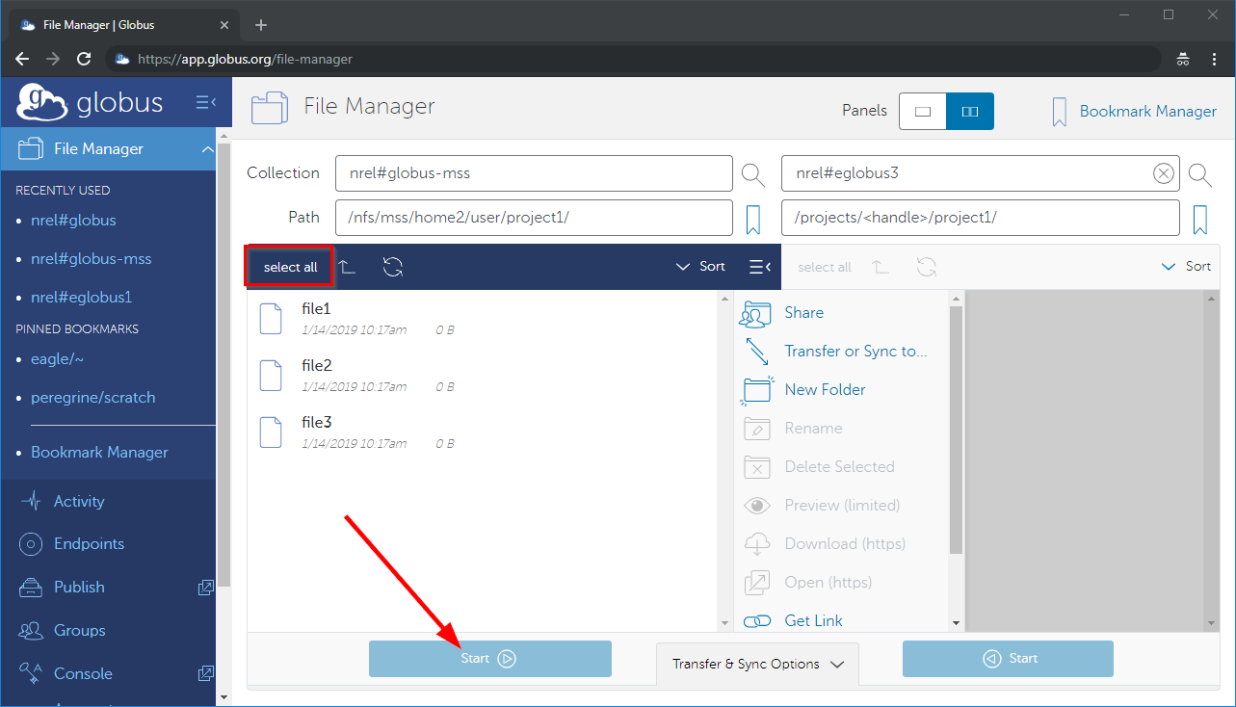

You should get a message “Transfer request submitted successfully. Task id: xxxxxxxxxxxxxx”

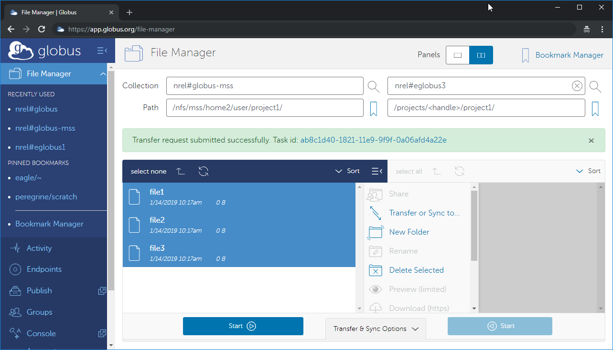

After the transfer is completed, which depends on the size of the transfer and how busy the endpoints are, you should get an email subject Globus Notification, body Succeeded.